



Cooperative Training Final Report
August-December 2024
A project submitted in partial fulfillment of the requirements for the degree of Bachelor of Business Administration in {Management Information Systems}

by
Aeshah Ali Alhabub
Supervised by
Dr. Khalid Albarrak

ACKNOWLEDGEMENT

All glory belongs to Allah, by whose dignity and majesty good actions are carried out. As this trip draws to a close, I would like to take a moment to thank everyone who has supported me over this time.
I would like to thank Dr. Khalid Albarrak for his unwavering leadership, which has helped me achieve every success and overcome every challenge.

As I reflect on the past five years, I am filled with gratitude for myself.
My unending study sessions, my sacrifices, and my steadfast determination to succeed despite all obstacles are evidence of my tenacity and dedication. I proudly and humbly acknowledge my diligence and tenacity in reaching this position.

I am appreciative of my family, especially my parents. Without your constant encouragement, sacrifices, and support, my journey would not have been possible. You have been there for me through all my triumphs and setbacks, offering me guidance, affection, and your unwavering belief in my potential. You have my eternal gratitude for making the sacrifices that allowed me to succeed.

And I can never adequately express my gratitude to my loved ones for your constant support and love. Your encouragement, understanding, and belief in my goals have continuously been a source of inspiration. When I am doubting myself, your voices are the ones that keep repeating in my mind, motivating me to keep going.

As I approach the close of this chapter, I carry with me the wisdom I have acquired, the cherished memories, and the love and support of each person listed here. I want to express my sincere gratitude to every one of you.

ABSTRACT

The remarkable experience of a co-op intern in Tamria AL Wissam organization Academy Development Division's Academic Programs & Partnership Department is highlighted in this abstract. Over the course of 19 weeks. This immersion program connected academic knowledge with real-world corporate training, fostering deep insights into organizational management.

Finding and fixing problems with the shared folder structure was a crucial part.
Through careful observation and in-depth research, the intern created technological communication between the institution's owners and clients with the goal of promoting collaboration among staff members, streamlining navigation, cutting down on waiting times, and facilitating easy communication.

This summary summarizes the interns' learning, creative, and problem-solving journeys while also highlighting their significant contributions to Saudi Aramco's training infrastructure. It is a tale of personal and professional development linked to noticeable increases in organizational efficacy.

Table of Contents
Introduction 6
Organization Overview 7
Tamira AL Wissam 7
Mission 7
Vision 7
Organization Structure 7
2. Training side department Academic Programing & Partnership Dept 8
2.1 Mission 8
2.2 Vision 8
2.3 Department Structure 8
2.4 Training side Division 8
2.5 Mission 8
2.6 Vision 8
2.7 Division Structure 9
3. The Journey Through Training 9
3.1 Training as CADD’s Intern 9
3.2 First period (August 25th – September 14th 9
3.3 Second period (September 14th - October 12th 9
3.4 Third period (October 13th – November 17th) 9
3.5 Fourth period (November 18th – December 19th 10
4. Initiative 10
4.1 Problem Statement 10
4.2 Initiative Description 11
4.3 Objective 11
4.4 Research Methodology 11
4.5 Context Diagram 11
4.6 Context Diagram Description 12
4.7 Tamira Al Wissam System 12
4.8 Data Flow Diagram (Level 0) 12
4.9 Data Flow Diagram (Level 0) Description 13
5. Entity Relationship Diagram 14
5.1 Logical database design 14
5.2 Physical database design 15
5.3 Mockup Design 15
Conclusion 18
References 18

Introduction
My co-op internship at Tamira AL Wissam was completed, serving as my bachelor's degree capstone experience. I had the honor of working in the Corporate Academy Development Div (CADD) for 19 weeks at the Academic Programs & Partnership Department (AP & PD). I made a significant contribution to the learning and development programs there that improved the abilities and productivity of workers. It was my responsibility to create and implement training programs that gave workers the essential information and abilities they needed to succeed in their positions and make a more meaningful contribution to the company's success.
This experience pushed me to be creative and analytical in my thinking about how to best meet the learning needs of a diverse workforce, in addition to allowing me to use my academic skills in a real-world situation. My grasp of corporate training and development has greatly improved as a result of the experience, which has also had a significant impact on my professional goals in organizational management.

Organization Overview

Tamira AL Wissam
Tamira and Shadiya Al-Wessam Foundation specializes in selling all types of luxury dates and includes many types of popular date sweets and Arabic sweets. It is considered an official sponsor in the governmental fields, companies and other institutions.

Mission
Our goal is to become the premier source for premium tamarind products in local markets by providing a distinctive experience that blends tradition and innovation to satisfy consumer preferences.

Vision
supplying the greatest varieties of dates and their products by utilizing the most advanced agricultural and production techniques.

Organization Structure
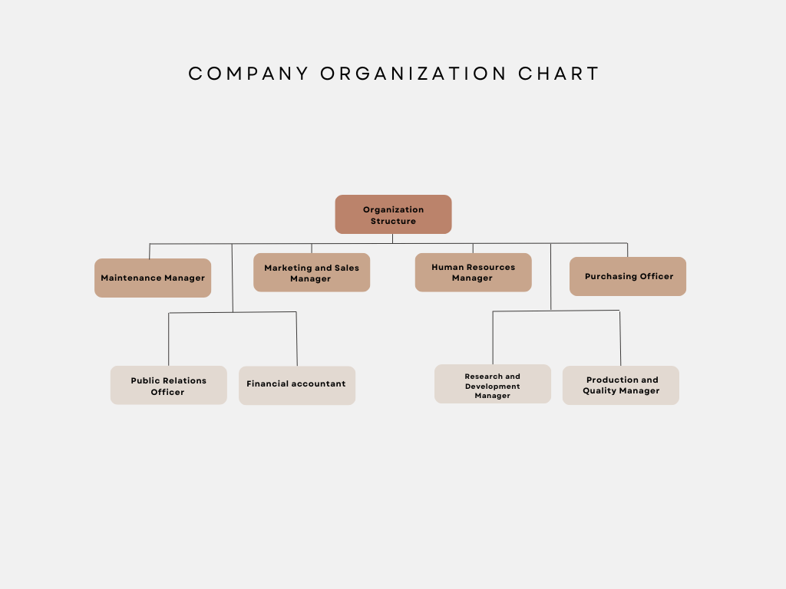

Figure 1: Organization Structure

2. Training side department Academic Programing & Partnership Dept

2.1 Mission
AP & PD is committed to developing a competent workforce in support of Tamira AL Wissam operations and the needs of the Kingdom by preparing qualified professionals to meet the organization strategic objectives.

2.2 Vision
Best-in-class learning enabler and provider.

2.3 Department Structure

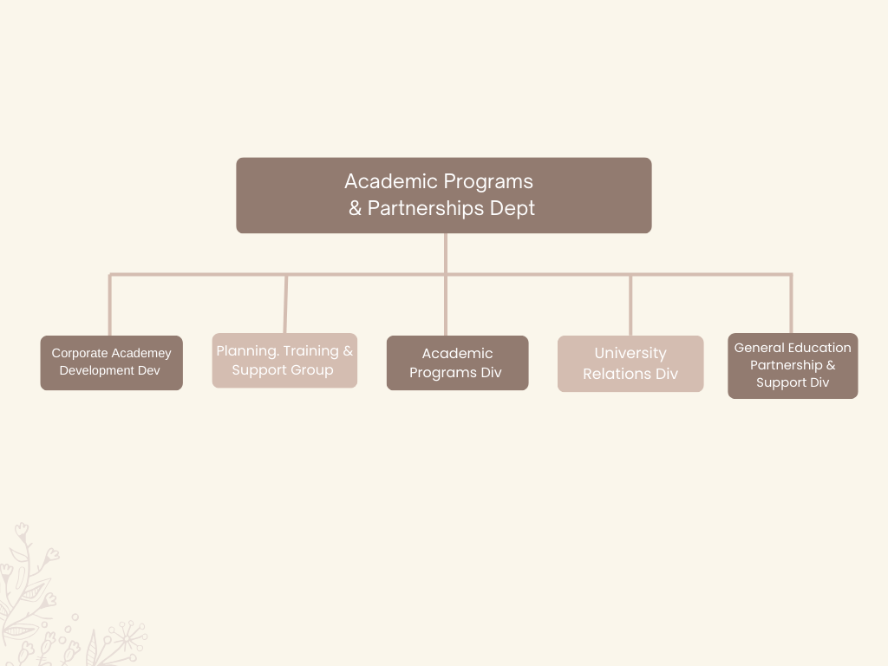Figure 2: Department Structure

2.4 Training side Division
Corporate Academy Development Div

2.5 Mission
We exist to equip professional employees with the right competencies for delivering on corporate objectives and priorities.

2.6 Vision
To align all professional learning under a strategic umbrella.

2.7 Division Structure
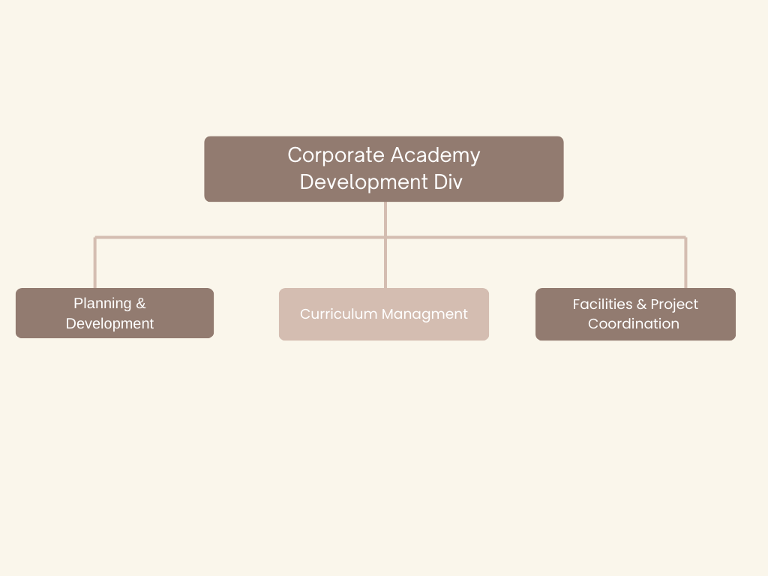

Figure 3: Division Structure

3. The Journey Through Training

3.1 Training as CADD’s Intern

3.2 First period (August 25th – September 14th)
I worked as a financial accountant, where I tracked the accounts and entered them into the organization’s system. I worked on arranging and redrafting the organization’s basic tables, such as employees’ salaries, products, and weekly and monthly official papers. I arranged the months’ bills and divided them according to each month. Sometimes I was asked to do specific designs, such as papers. Official

3.3 Second period (September 14th - October 12th)
During this period, I undertook the task of photographing all kinds of products and publishing them on the organization’s official account via WhatsApp and Instagram, in addition to designing posters in the event of discount offers or announcing the availability of new products. On the other hand, I conducted research on the organization’s need to develop it to write the initiative to communicate with customers on a regular basis. Mobile phones to carry out special requests or inquire about prices

3.4 Third period (October 13th – November 17th)
I was a Responsible for purchasing and improving the organization's disbursement amount
I found that there is a problem that the institution suffers from. I have developed a comprehensive plan for all costs specialized in procurement, such as raw materials and products, including dates, consumables, and foodstuffs, searching for high-quality and low-priced alternatives, and making recommendations for places to deal with in providing the institution with the best types of data and consumables.

3.5 Fourth period (November 18th – December 19th)
App developer for the organization.
Based on the support of supervisor Abdullah Al-Mubarak it does not know the enterprise electronics application highlights all products and news the site is characterized by speed and ease of use thanks to what it uses SWIFT easy to use giving them a comprehensive overview this application improves the organization online position. Attend and interact with the audience through it.

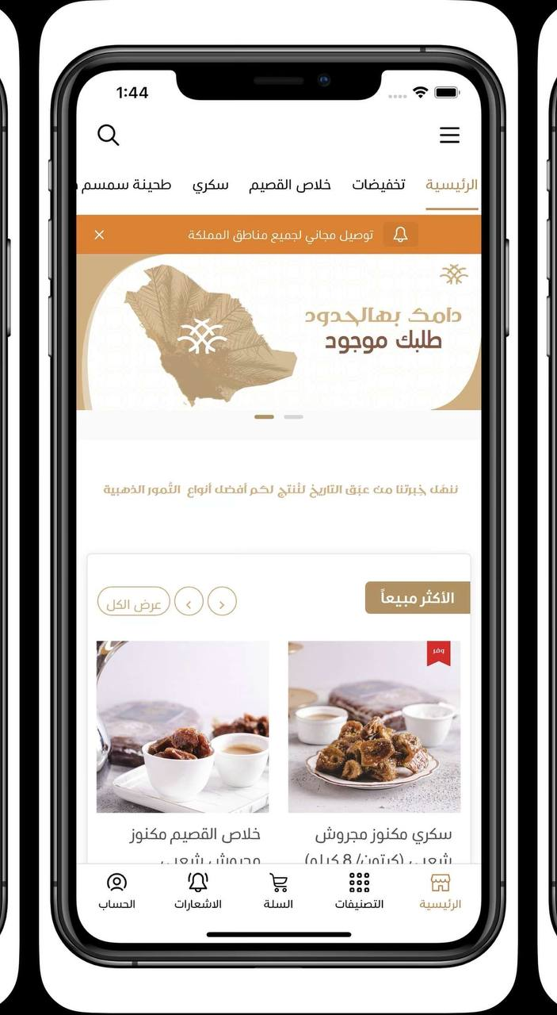
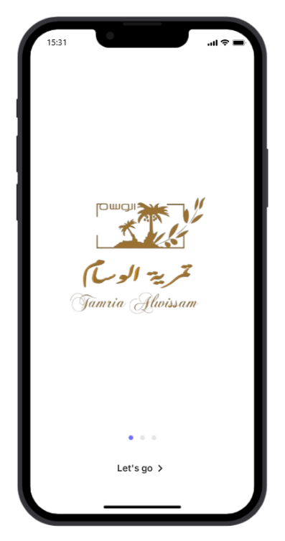

Figure 3: Implement

4. Initiative

4.1 Problem Statement
As an intern that has access to the shared folders I faced some challenges:

- I noticed that during my training there, the organization did not have its own website or electronic application to publish new products and discounts.

- Many people were communicating by phone or WhatsApp just to find out the types of dates available, their sizes and prices, which put great pressure on the person responsible for communicating with customers.

- when ordering products in specific quantities outside Al-Ahsa, and many times outside Saudi Arabia, this is done by the customer coming from his area to the store to make an order and have it delivered to his home, which leads to the loss of customers many times.

- The lack of clear pictures of products of various sizes to explain them to customers through social media, plates for occasions in all their forms, writing phrases, bags and how to package them.

4.2 Initiative Description
Creating an electronic application that serves the organization and developing it from the technical side and to solve the problems that employees in the organization face with customers during inquiries about the products and services provided by the store, also, to win customers from all regions and countries and to organize the process of receiving their requests.

4.3 Objective
- Improve the division's communication.
- Facilitating the process of browsing products and switching between them
- Time saving.

4.4 Research Methodology
The observational research approach was chosen because of its apparent capacity to effectively gather a substantial amount of data, following over four months of employee

4.5 Context Diagram

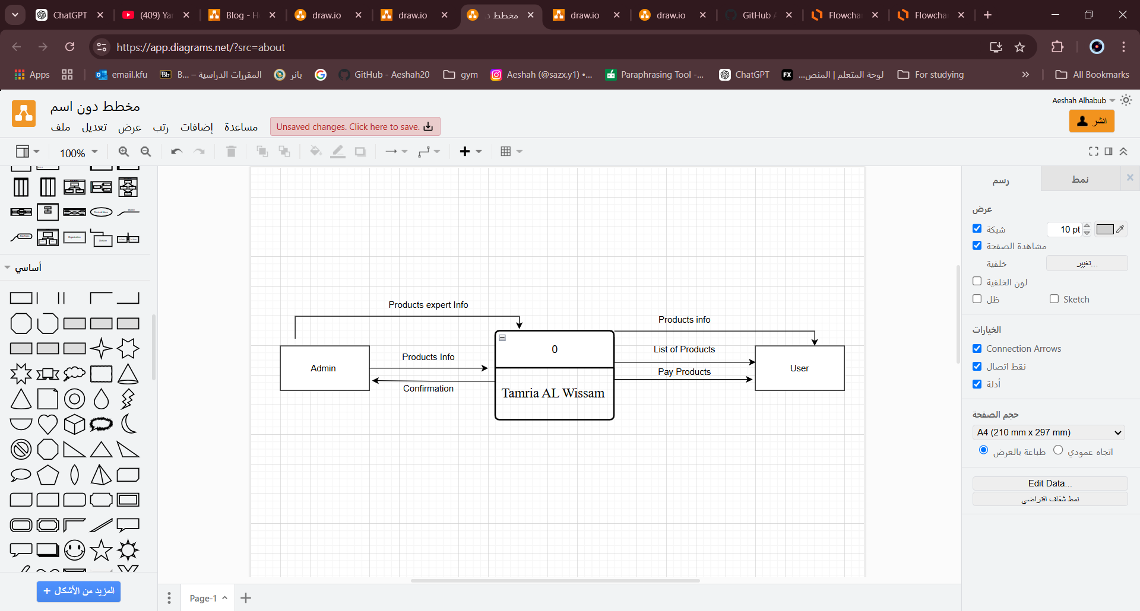

Figure 5: Context Diagram

4.6 Context Diagram Description
This diagram shows the components of the system and how it generally works.
We have 2 Entities; each one has a specific role.
Admin: who can manage inventory, orders, user accounts
Customers / user: look over products who can pay and monitor delivery

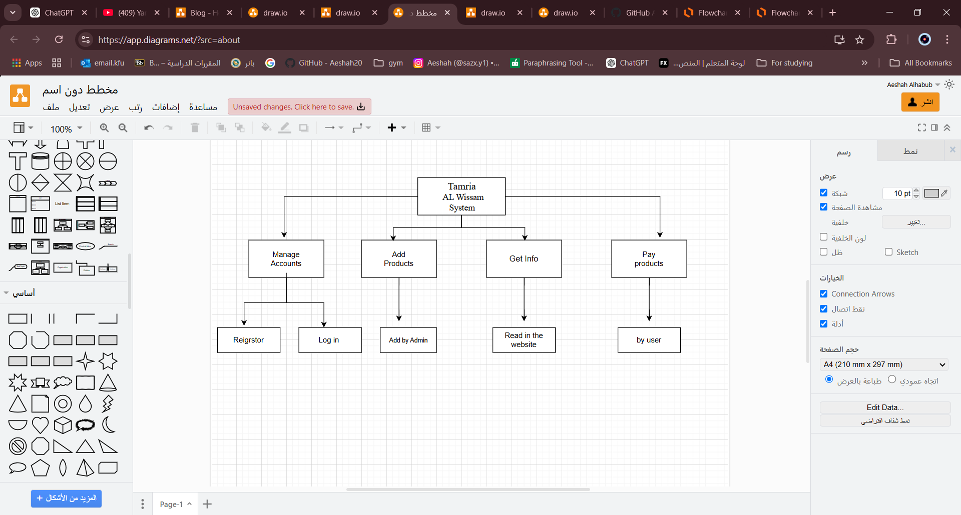
4.7 Tamira Al Wissam System

Figure 6: Tamira Al Wissam System

4.8 Data Flow Diagram (Level 0)
This diagram shows the processes of the system and how it works.
After Register and log in will:

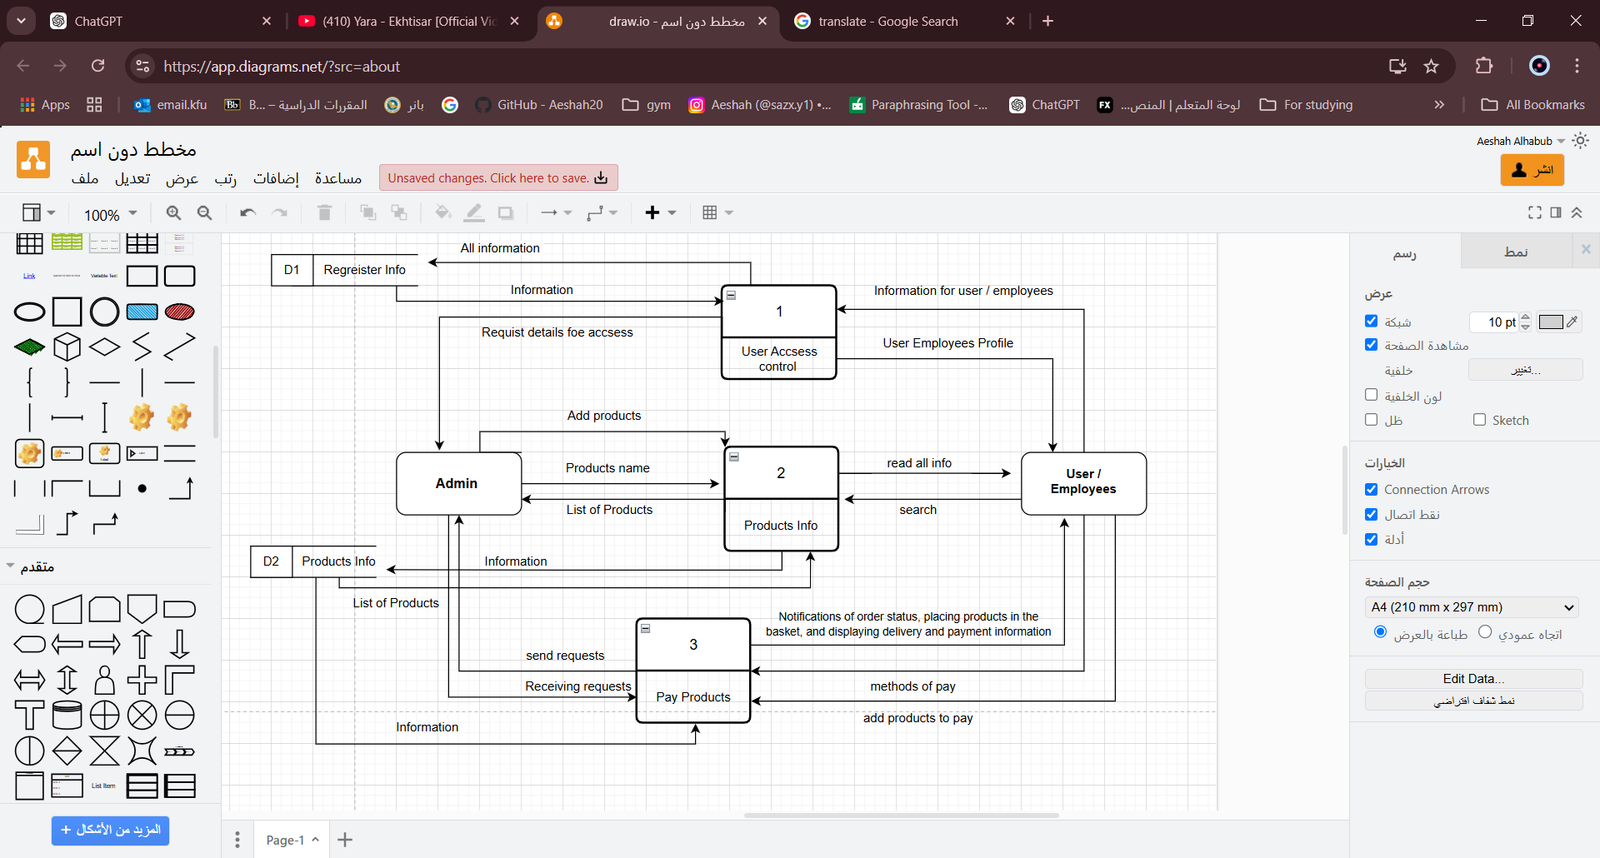
Figure 7: DFD

4.9 Data Flow Diagram (Level 0) Description
- User Access control: In the first step, the user will register an account and enter all the required data to be able to pass the first stage
- Products Information: In this step, the user can browse the products and read the information related to them that the manager added, such as prices and names
- Pay Products: While the user places the products he wants to buy, several steps will appear to him, such as the appropriate payment method. He can view the basket containing the products and send his request, awaiting acceptance, to complete the order and payment process.

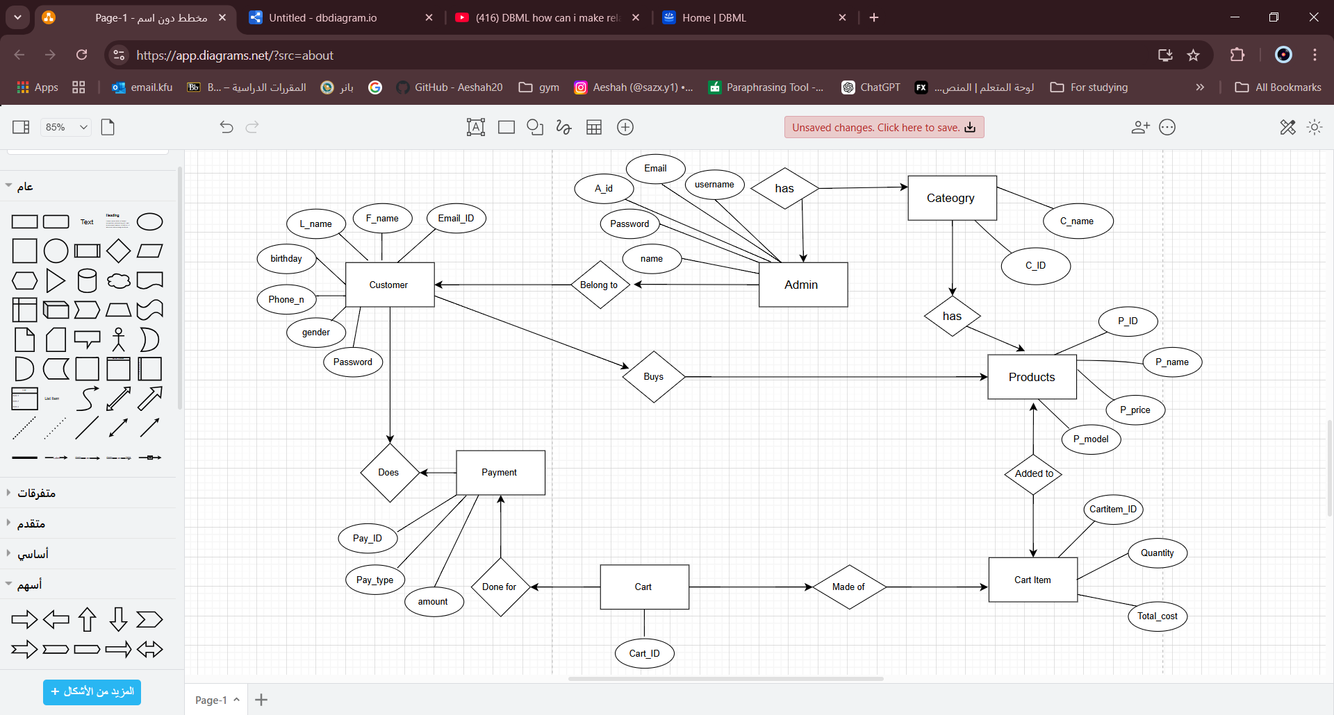
5. Entity Relationship Diagram

Figure 8: Entity Relationship Diagram

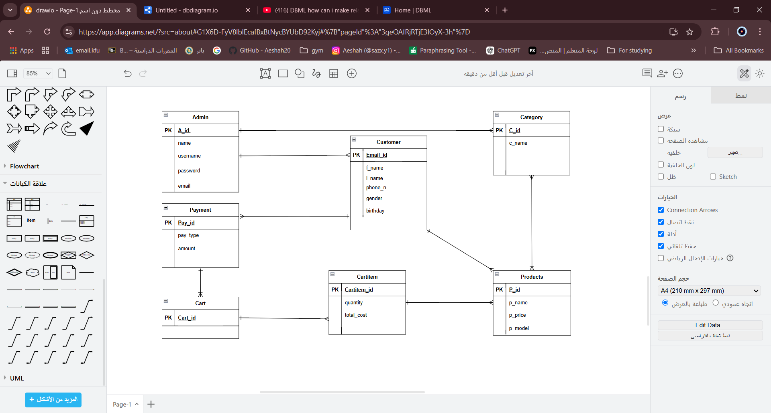
5.1 Logical database design

Figure 9: Logical database design

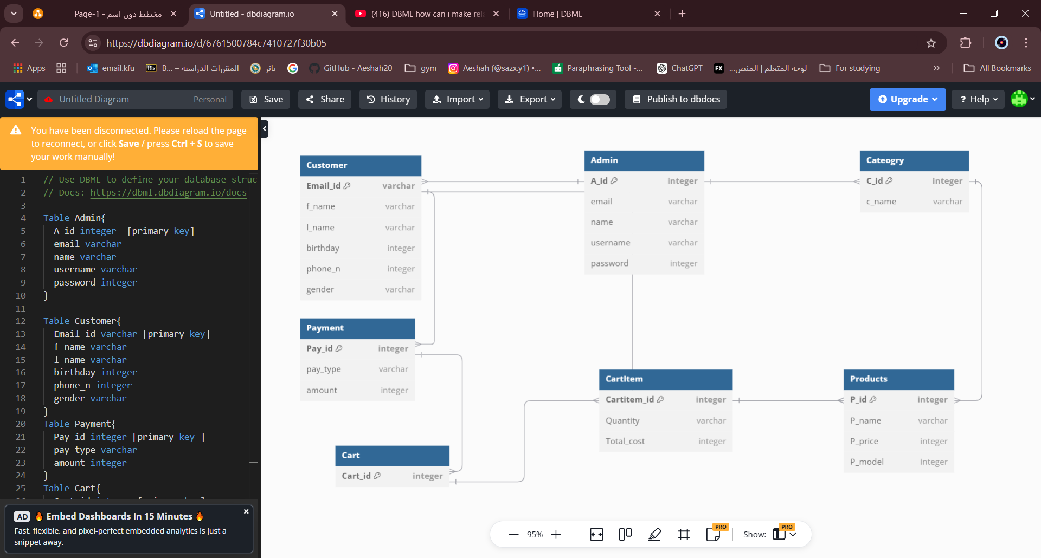
5.2 Physical database design

Figure 10: Physical database design

5.3 Mockup Design


There is a first page user he will see it when opening the Application. Organization LOGO

Figure 11: Open Application



The user can see the best-selling products on the home page and the offers, and at the top of the page there will be special discounts for the first time the user registers with the application or for traditional occasions such as National Day, Teacher’s Day, and Founding Day.

Figure 12: Home page

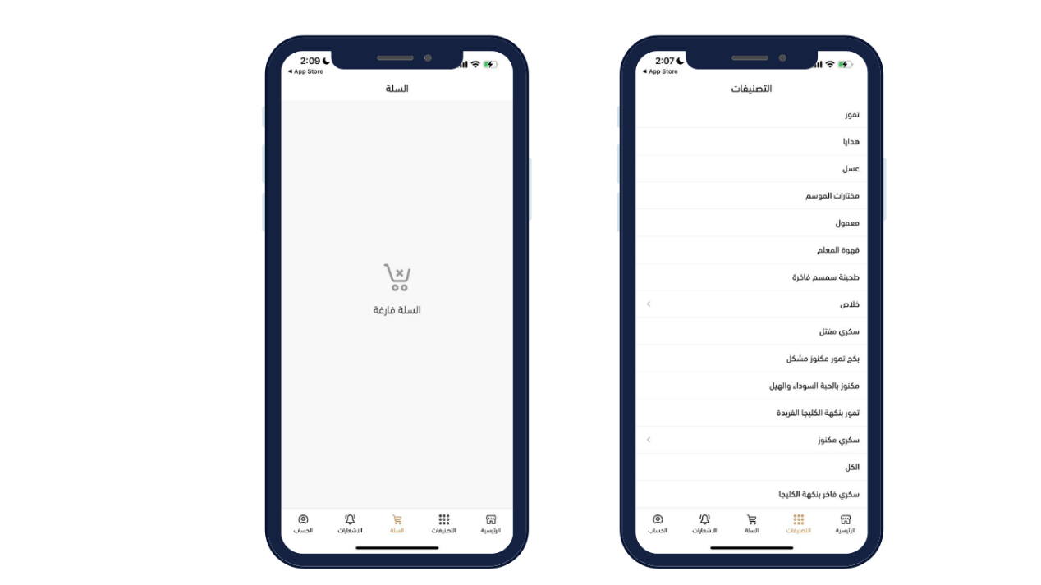

Here is the categories page containing all the products
And also, the cart page to place products in

Figure 14: Categories and Cart page

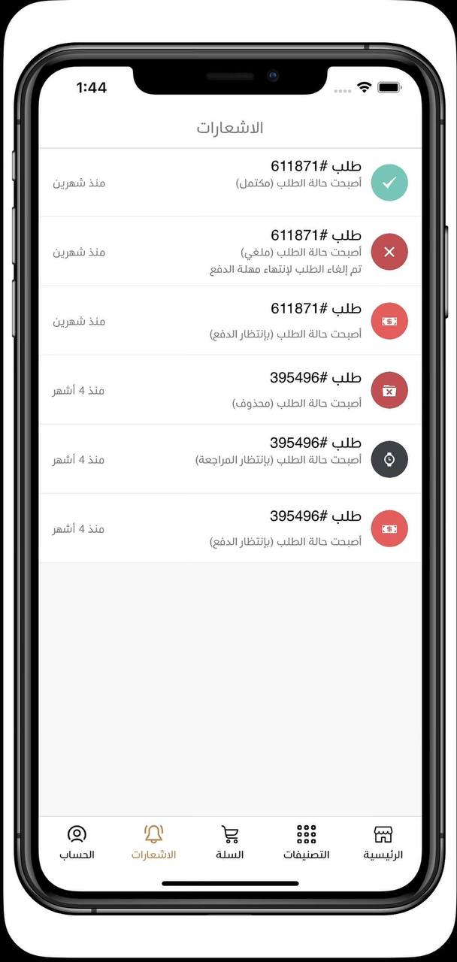

Here the user can view the order number, when he ordered it, and how the order status is

Figure 15: Notification

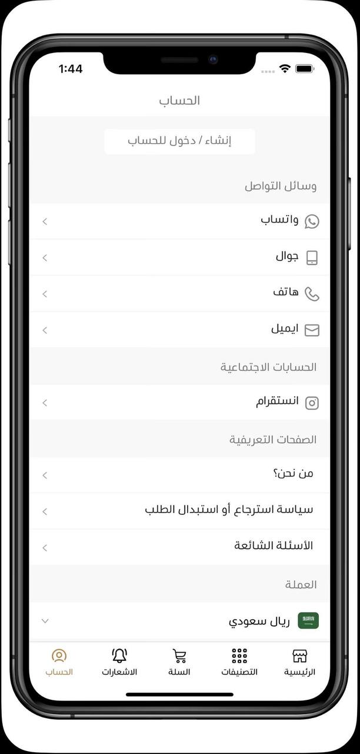

At Account you can log in or create new account , there is multiple methods to connection.

Figure 16: Account

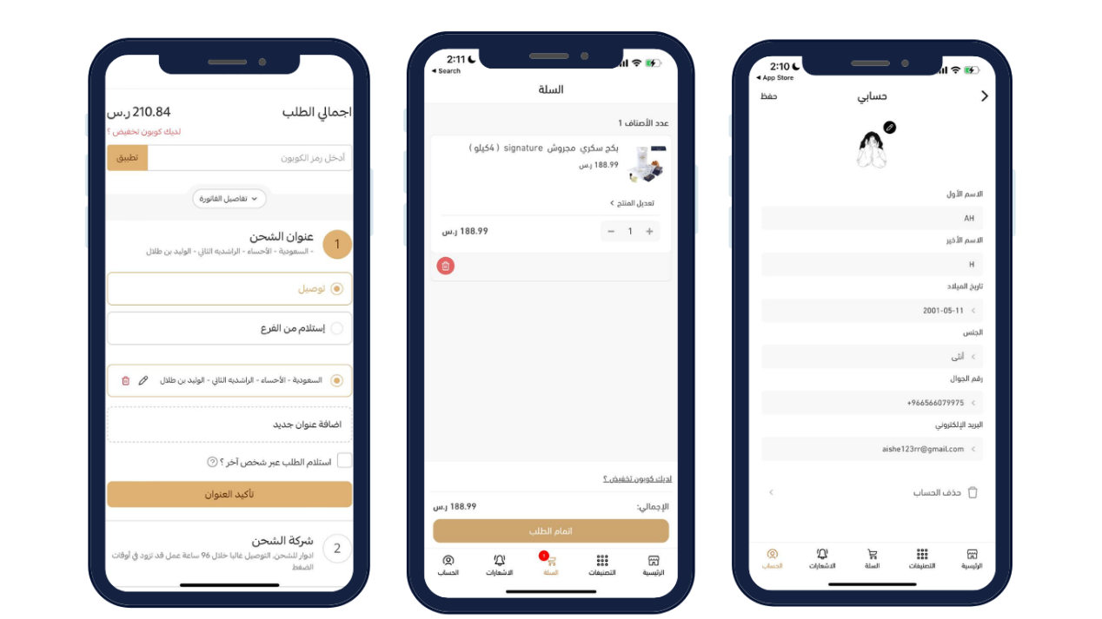

Figure 17: my account

Conclusion
In conclusion, my co-op internship has been an amazing experience that has significantly increased my knowledge and expertise in corporate training and development in addition to helping me achieve the maximum level of my bachelor's degree. For almost 19 weeks, I had the privilege of greatly enhancing workers' learning and development programs at the Corporate Academy Development Division (CADD), which is part of the Academic Programs & Partnership Department (AP & PD). My ability to create and implement effective training programs has improved as a result of this experience, which has also helped me better grasp the challenges of meeting the diverse learning needs of a large and dynamic workforce.

References
(2024). Tamira Al Wissam Annual Report. Tamira Al Wissam:
https://www.instagram.com/alwissam2/?hl=ar

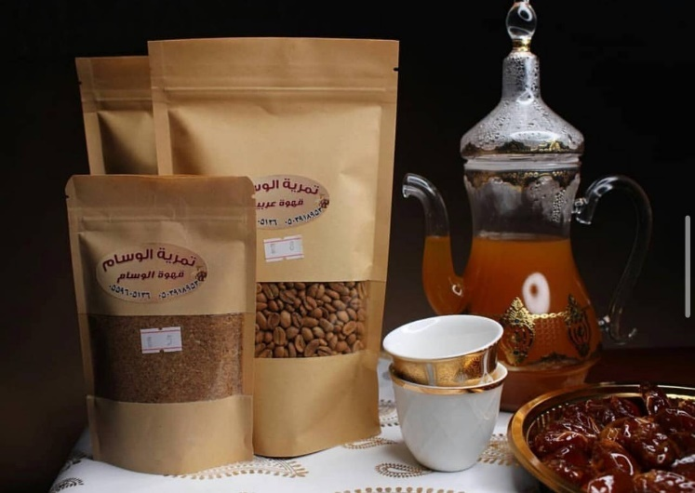
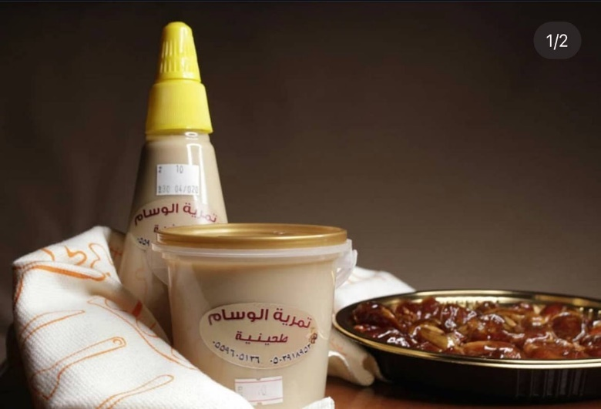
Appendixes


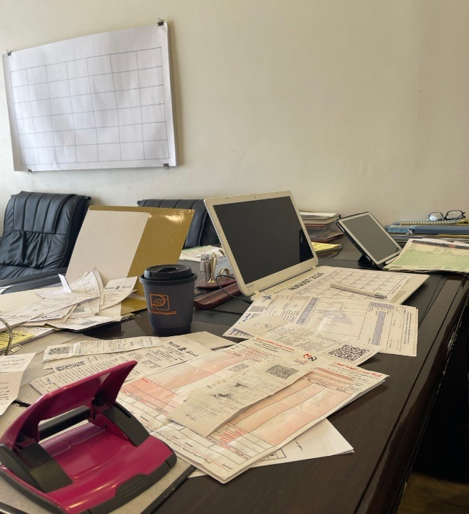
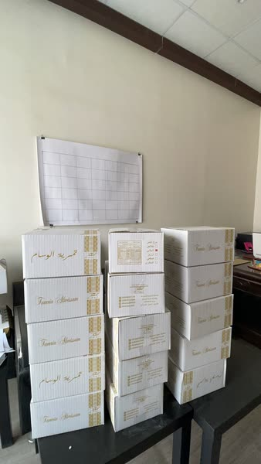
Some of my pictures for products

